**TITLE: VIRTUAL VOICE ASSISTANT**

**LOVELY PROFESSIONAL UNIVERSITY**

Course code: INT 404

Course Title : Artificial Intelligence

**Project Description**

This project is a virtual voice assistant which is coded in python language. In this we give input as a voice command to the system and it will react back to us in voice and display the text as well of which we spoken and command we gave. It has five basic commands they are:

‘what is your name’, ‘what time is it’, ‘search’, ‘find location’, ‘exit’.

**Output Description:** When we execute this It first asks us ‘How can I help you’ then we have to give any of the above five commands, if we give ‘what is your name’ it returns back ‘my name is assistant’, if we ask for what time is it, it will speak out the time and displays it, if we say search it will ask ‘what do you wanna search for’, we will give input voice for what we wish to search same in case of ‘find location’ it will ask for ‘which location do you wanna find for’, In case of search it will redirect to chrome and in case of ‘find location’ it will redirect to google maps and speak ‘Here is what I found for location + location’ and in case of search ‘Here is what i found for + search’. If we say ‘exit’ it will exit our program. If we don’t have internet services it says my services are down and if it doesn’t understand the command given it says sorry I didn’t get that.

**Libraries used**

**gtts, time, ctime, web browser, speech recognition, pyaudio, playsound, os, random.**

**gtts : ‘**google text to speech’, it is used to convert the given text into speech.

**speech recognition :** It is used to take input of voice command and conver it into text using recognize_google() function.we can use not only google but many engines available like alexas and e.t.c.

**ctime :** It is used to take the system date and time and give to our assistant.

**time :** It is used to ask the user input if we set it to 1 untill he says exit.

**web browser :** It is used to connect to google chrome and google maps it work as a sourc e of internet, basically it is a inbuilt module we have no externally install it.

**pyaudio :** It is also a prerequisite module to conver text into speech.

**playsound :** playsound is used to play the files which has been saved means the give input or output voices which are saved.

**os** : os is used to save or remove audio files which are input and output voices.

**random**: random is used to generate a random number in the given range In our program it is used to save the files along with a random number to make difference between audio clips.

**Note : These all libraries except random, time, ctime all are externally installed to run this program these libraries should be pre-installed in the system.**

**Code**

import speech_recognition as sr

from time import ctime

import webbrowser as wb

import time

import pyttsx3

from gtts import gTTS

import os

import time

import playsound

import random

import pyaudio

r=sr.Recognizer()

def record_audio():

with sr.Microphone() as source:

audio=r.listen(source)

voice_data=''

try:

voice_data=r.recognize_google(audio,language='eng-in')

except sr.UnknownValueError:

speak("sorry i didn't get that")

except sr.RequestError:

speak("sorry my services are currently down")

return voice_data

def speak(text):

tts=gTTS(text=text,lang='en')

r=random.randint(1,10000000)

filename="voice"+str(r)+".mp3"

tts.save(filename)

playsound.playsound(filename)

print(text)

os.remove(filename)

def respond(voice_data):

if 'what is your name' in voice_data:

speak('My name is assistant and I am assistant of you')

print('My name is assistant and I am assistant of you')

if 'what time is it' in voice_data:

time=ctime()

print(time)

speak(time)

if 'search' in voice_data:

print('what do you wanna search for')

search=record_audio()

url='https://google.com/search?q=' + search

wb.get().open(url)

speak('Here is what i found for'+search)

print('Here is what i found for'+search)

if 'find location' in voice_data:

speak('which location you wanna find for')

print('which location you wanna find for')

location=record_audio()

url='https://google.nl/maps/place/' + location + '/&amp;'

wb.get().open(url)

speak(‘Here is what I found for location’+location)

print((‘Here is what I found for location’+location)

speak('How can i help you')

voice_data=record_audio()

respond(voice_data)

**Learning outcomes of this project**

I have learnt so much from this project. I have learnt all the above mention libraries very well with this knowledge I got the confidence to build any other voice based applications. There are many errors while the installation of libraries it also requires a lot of tricks and efforts I also got the knowledge of how to install the libraries if error comes while installation.

**Screenshots of output**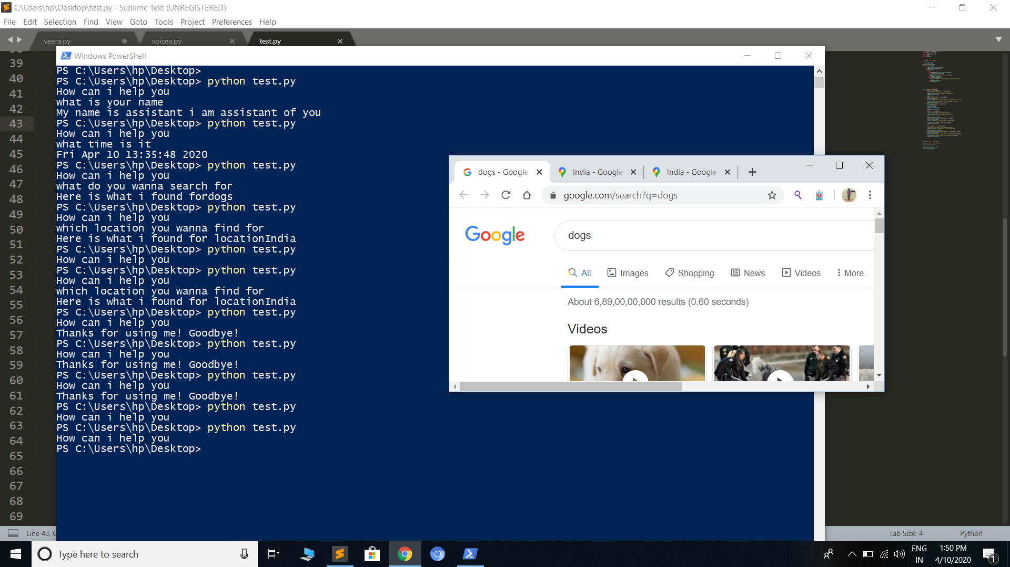

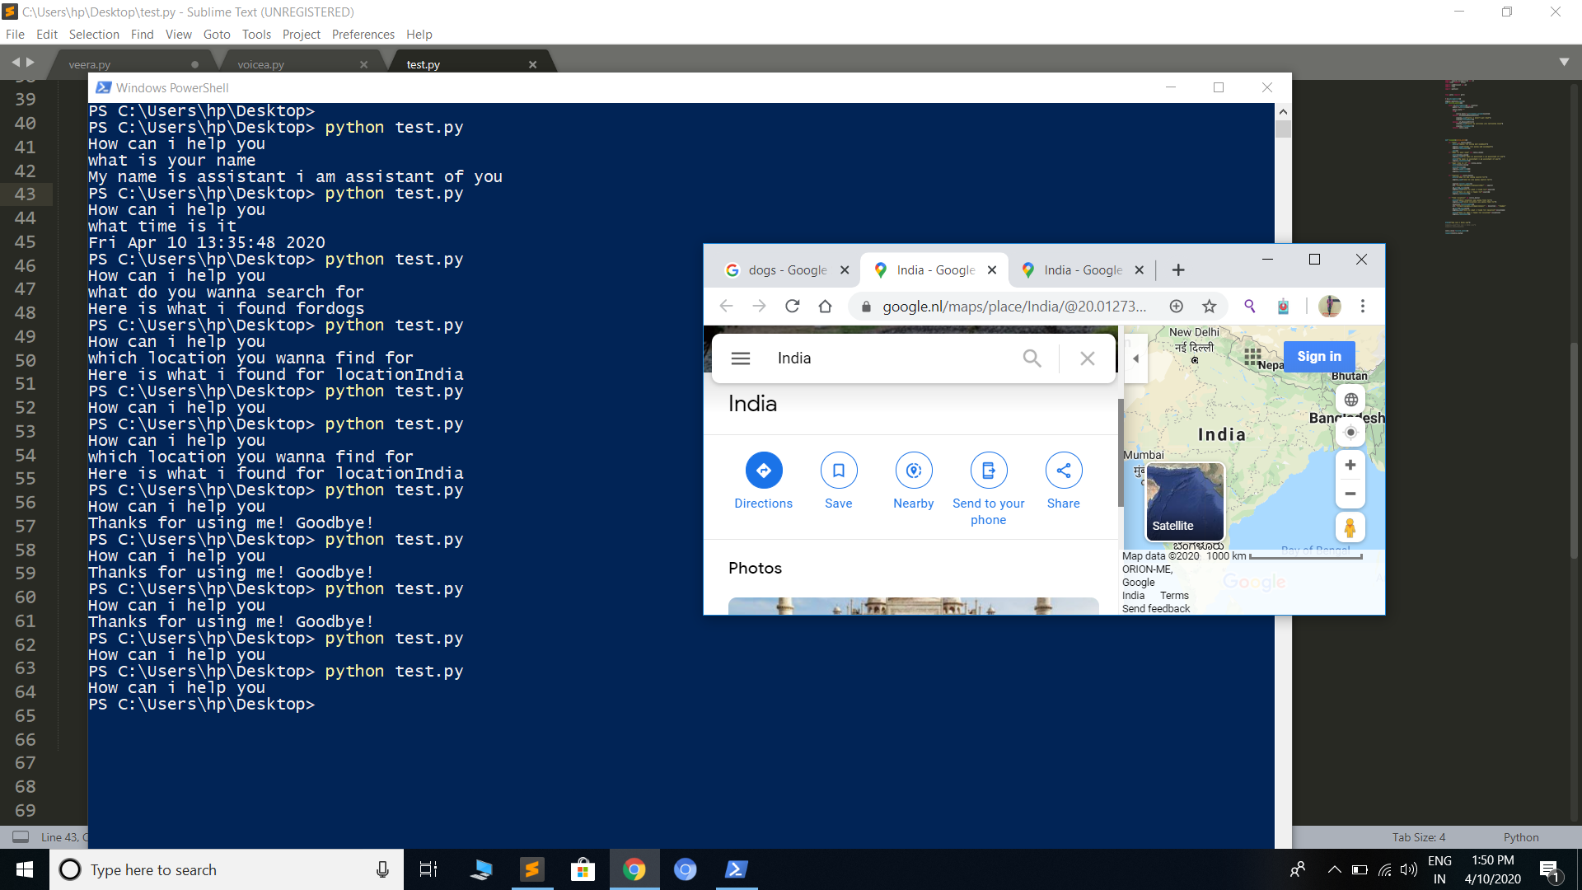

**Voice files generated if we do not use os.remove()**

